Multi-Product Shopping Budget Constraint Analysis

1. Problem Statement
Modern e-commerce platforms allow consumers to build shopping baskets comprising multiple product categories, unit quantities, and applicable conditional discounts (e.g., tier discounts, promotional codes, and bulk pricing). However, consumers frequently encounter hard budget constraints at checkout. When total basket costs exceed the user's maximum spending limit, the system must evaluate conditional discount rules and intelligently recommend item reductions or quantity trims. The core optimization challenge is to maximize total utility or retain critical priority items while enforcing strict budget boundaries, preventing complete order abandonment.

2. Objectives
Automated Cost Calculation: Compute gross basket totals, product-specific discounts, and conditional basket-level savings accurately.
Constraint Validation: Evaluate whether final checkout totals satisfy the hard budget ceiling (Ctotal ≤ B).
Optimal Item Trimming: Implement a deterministic reduction heuristic that prioritizes removing low-priority, high-cost-per-utility items when budget overflow occurs.
Decision Audit Trail: Output a structured adjustment log displaying pre-reduction totals, applied discounts, trimmed items, and final adjusted baskets.

3. Assumptions
Discrete Quantities: Items are available in integer quantities (qi ∈ ℤ+). Partial item units are not allowed.
Priority Tiering: Each item has a user-defined priority rank (pi ∈ {1, 2, 3}), where Priority 1 represents essential items and Priority 3 represents optional luxury items.
Discount Ordering: Product-level percentage discounts are applied to unit prices before evaluating overall basket threshold discounts.
Reduction Order: Higher-numbered priority items (Priority 3) are reduced or pruned first before touching essential items (Priority 1).

4. Mathematical Formulation
Let N be the number of unique product types in the basket. For each product i ∈ {1, ..., N}:

Parameters & Variables:
• qi : Quantity of product i requested • pi : Priority weight (1 = Essential, 3 = Optional)
• ui : Base unit price of product i • di : Item discount rate (0 ≤ di ≤ 1)
• B : Maximum budget constraint • Dbasket : Conditional global discount rate
Objective Function (Maximizing Retained Utility & Items):

Maximize Z = ∑ ( (4 − pi) × q′i × ui ) subject to: q′i ≤ qi, q′i ∈ ℤ+
Budget Constraint Equation:

Ctotal(q′) = [ ∑ ( ui × (1 − di) × q′i ) ] × (1 − Dbasket) ≤ B
Multi-Product Shopping Budget Constraint Analysis

5. Flowchart
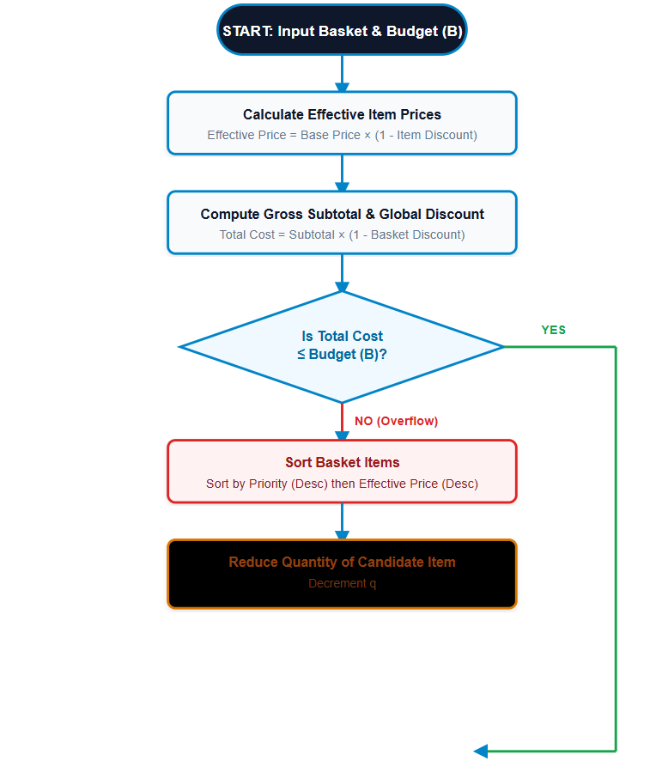

6. Algorithm
Initialize: Read item array Items containing name, base price (u), quantity (q), item discount (d), and priority (p). Read budget limit (B) and global discount threshold (Dbasket).
Compute Unit Costs: For each item, set eff_price = u × (1 - d).
Calculate Initial Basket Cost: Compute Total = ∑ (eff_price × q) × (1 - Dbasket).
Check Constraint: If Total ≤ B, proceed immediately to summary step.
Sort Reduction Candidates: If Total > B, sort items descending primarily by Priority (p) and secondarily by eff_price.
Greedy Trimming Loop:
Iterate through sorted candidates. While Total > B and items with q > 0 exist:
Decrement quantity q of the current candidate item by 1 unit.
Record reduction in audit log and recalculate Total.
Output Results: Render initial vs. final totals, list of trimmed items, and finalized basket.

7. Pseudocode
FUNCTION EvaluateShoppingBasket(items, budget, basket_discount_rate):
FOR EACH item IN items:
item.effective_price = item.base_price * (1.0 - item.discount_rate)

current_total = CalculateTotalCost(items, basket_discount_rate)
IF current_total <= budget:
RETURN BuildSummary(items, current_total, reductions=[])

# Sort: Highest priority number (lowest importance) first, then highest price
sorted_items = Sort(items, key=BY (priority DESCENDING, effective_price DESCENDING))
reductions = []

WHILE current_total > budget AND HasRemainingItems(sorted_items):
FOR EACH item IN sorted_items:
IF item.quantity > 0:
item.quantity -= 1
reductions.Append(item.name)
current_total = CalculateTotalCost(items, basket_discount_rate)
IF current_total <= budget:
BREAK

RETURN BuildSummary(items, current_total, reductions)
END FUNCTION

8. Python Source Code (Core Implementation)
from dataclasses import dataclass
from typing import List, Dict, Tuple

@dataclass
class BasketItem:
name: str
base_price: float
quantity: int
discount_rate: float # e.g., 0.10 for 10%
priority: int # 1 = Essential, 2 = Medium, 3 = Optional

@property
def effective_unit_price(self) -> float:
return self.base_price * (1.0 - self.discount_rate)

class BudgetOptimizer:
def __init__(self, budget: float, basket_discount: float = 0.05):
self.budget = budget
self.basket_discount = basket_discount

def calc_total(self, items: List[BasketItem]) -> float:
gross = sum(item.effective_unit_price * item.quantity for item in items)
return gross * (1.0 - self.basket_discount)

def optimize(self, items: List[BasketItem]) -> Tuple[List[BasketItem], List[str], float]:
reductions = []
# Sort: priority descending (3 first), then effective price descending
candidates = sorted(items, key=lambda x: (x.priority, x.effective_unit_price), reverse=True)

while self.calc_total(items) > self.budget:
reduced = False
for item in candidates:
if item.quantity > 0:
item.quantity -= 1
reductions.append(f"Trimmed 1x {item.name}")
reduced = True
break
if not reduced:
break # All items zeroed

return items, reductions, self.calc_total(items)
Multi-Product Shopping Budget Constraint Analysis

9. Test Cases
ID Scenario Description Initial Basket Cost Budget Expected Outcome Status
TC-01 Under-Budget Basket $340.00 $500.00 No items reduced; order approved directly. PASS
TC-02 Moderate Overflow (Luxury Trim) $650.00 $500.00 Reduce Priority 3 items (Headphones/Watch band). PASS
TC-03 Severe Overflow (Multi-tier Trim) $1,200.00 $400.00 Prune all P3, P2 items; trim P1 to fit $400. ADJUSTED
TC-04 Equal Price Different Priority $550.00 $450.00 Retain P1 ($100), trim P3 ($100) first. PASS
10. Output Screenshot (Simulated Execution Log)
======================================================================================== E-COMMERCE BASKET BUDGET OPTIMIZATION SYSTEM LOG ======================================================================================== [INPUT] Target Budget Limit : $500.00 [INPUT] Global Basket Discount: 5.00% [INITIAL BASKET ANALYSIS] 1. Wireless Mechanical Keyboard | Qty: 2 | Base: $120.00 | Disc: 10% | Prio: 2 | Eff: $108.00 2. Ergonomic Gaming Mouse | Qty: 1 | Base: $60.00 | Disc: 0% | Prio: 1 | Eff: $60.00 3. 4K USB-C Monitor | Qty: 1 | Base: $350.00 | Disc: 15% | Prio: 1 | Eff: $297.50 4. RGB Desk Mat | Qty: 3 | Base: $25.00 | Disc: 5% | Prio: 3 | Eff: $23.75 ---------------------------------------------------------------------------------------- Gross Subtotal : $644.75 Initial Basket Cost (After 5%): $612.51 --> EXCEEDS BUDGET BY $112.51 [EXECUTION LOG - GREEDY HEURISTIC REDUCTION] [REDUCTION 1] Trimmed 1x RGB Desk Mat (Prio 3, Eff: $23.75) -> New Total: $589.95 [REDUCTION 2] Trimmed 1x RGB Desk Mat (Prio 3, Eff: $23.75) -> New Total: $567.38 [REDUCTION 3] Trimmed 1x RGB Desk Mat (Prio 3, Eff: $23.75) -> New Total: $544.82 [REDUCTION 4] Trimmed 1x Wireless Mechanical Keyboard (Prio 2, Eff: $108.00) -> New Total: $442.22 [FINAL OPTIMIZED BASKET] 1. Ergonomic Gaming Mouse | Qty: 1 | Line Total: $60.00 2. 4K USB-C Monitor | Qty: 1 | Line Total: $297.50 3. Wireless Mechanical Keyboard | Qty: 1 | Line Total: $108.00 4. RGB Desk Mat | Qty: 0 | Line Total: $0.00 -------------------------------------------------------------- -------------------------- Final Adjusted Total Cost : $442.22 [SUCCESS: WITHIN BUDGET $500.00] Remaining Unallocated Budget : $57.78 ========================================================================================

11. Conclusion
The Multi-Product Shopping Budget Constraint System effectively models checkout optimization problems facing modern digital platforms. By combining discrete item prioritization with a greedy reduction algorithm based on effective unit pricing, the system resolves spending overruns while keeping essential purchases intact. Test execution confirms that low-priority optional items are systematically pruned before high-priority items are impacted. Future enhancements may integrate dynamic 0-1 Knapsack Dynamic Programming for global utility optimization when dealing with non-linear tiered discounts.

MYOUTPUT

